**Ransomware: Evolution, types, and Preventions**

*Le Manh Cuong – Student ID:19021231*

*INT 3307_21- Network safety and Security*

*VNU University of Engineering and Technology*

*VNU-UET*

*Due Date: 10/1/2022*

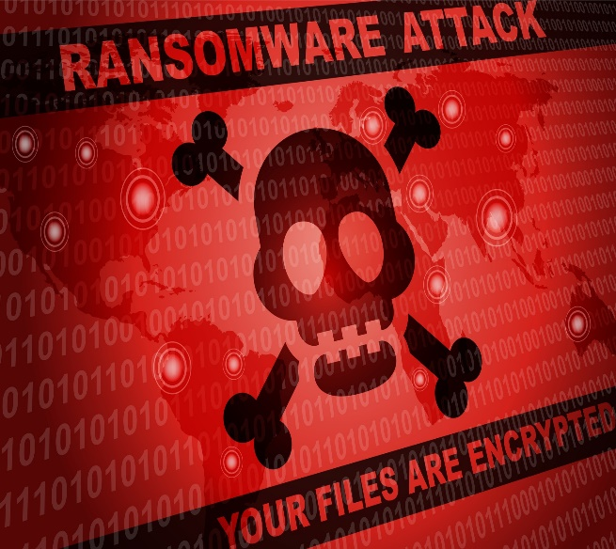Abstract

Under the influence of covid, the Internet has become closer to people than ever. Therefore, new technologies were born to meet the needs of people's daily lives. Creates a huge opportunity for cybercriminals to make millions of dollars with malware. The most notable is ransomware - a notorious piece of malware that is still growing rapidly. In recent years, ransomware is one of the most notorious malware that targets end-users, governments, and business organizations. In this article, we present a brief history of ransomware, arguments for and against paying the ransom, prevention best practices to protect your computer from several types of Ransomware running popular today.

Table of Contents

I. Introduction: an overview of ransomware 3

II. Literature survey 4

1. Evolution of ransomware 5

2. Types of RANSOMWARE 7

**a)** Crypto ransomware or encryptors 7

b) Screen Lockers: 7

3. Ransom should be paid or not 8

4. Key Ransomware challenges and prevention techniques 9

III.Conclusions 9

IV.References 9

# I. Introduction: an overview of ransomware

Nowadays, the number of internet users is out increasing rapidly. Specifically, up to now, there are nearly 4.66 billion internet users worldwide with a rate of 59.5%. With such a large number of users, there are many development opportunities for enemies to attack the network. Therefore, cybercrime is increasing day by day and creating many dangers to users and many problems for network security. One of the scary enemies is a Ransomware attack.

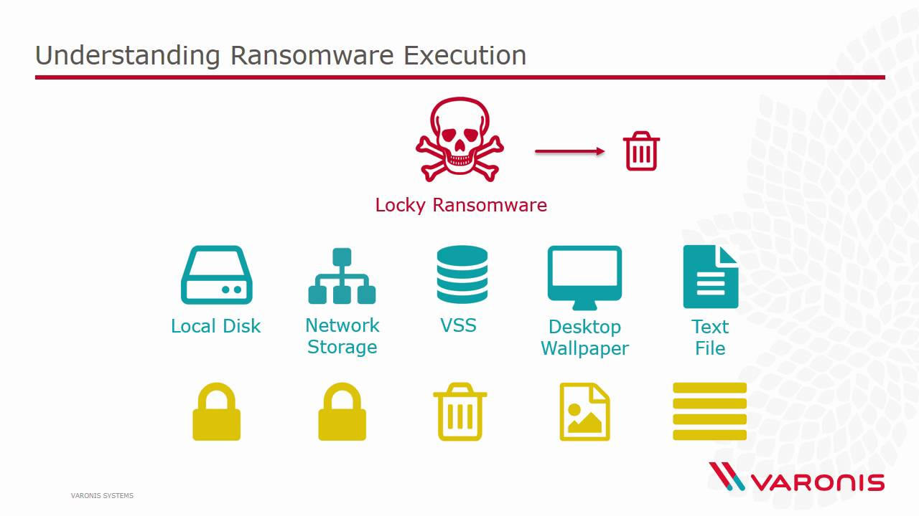

**As defined by Wikipedia:** *Ransomware is a type of malware from cryptovirology that threatens to publish the victim's data or perpetually block access to it unless a ransom is paid. While some simple ransomware may lock the system so that it is not difficult for a knowledgeable person to reverse, more advanced malware uses a technique called cryptoviral extortion. [1]*

Ransomware is a growing form of computer crime that is hitting all types of organizations, including law enforcement. Ransomware is malicious software that once loaded on a victim system encrypts the hard drive and issues a warning that unless a ransom is paid within a short time, all the data will become unrecoverable. The software then tells the victim to typically spend between $250 and $1,000 to the criminal within the allotted period, usually via bitcoin. When the ransom is paid, the criminal will send the victim an alphanumeric sequence to unlock the malware.

At its heart, this form of digital extortion can be broken down into two major types, and then subdivided based on the families they represent. The two major forms of ransomware are those that encrypt, obfuscate, or deny access to files and those that restrict access or lock users out of the systems themselves. These threats are not limited to any particular geography or operating system and can take action on any number of devices. Everything from your Android devices, iOS systems, or Windows systems all is at risk of this type of exploitation via ransomware. Depending on the target, the method of compromise of the device may be different, and the final actions taken would be limited by the device’s capability itself, but there are also recognizable patterns that many extortionists follow.[]

The victims are usually by clicking on some phishing message or downloading some malware that impersonates the ransomware of malicious websites. To then have to pay a ransom in a relatively short time because to prevent the victim from finding alternative decryption methods.

Ransomware remains one of the most profitable tactics for cybercriminals. According to Cybersecurity Ventures, the global cost of ransomware in 2020 is estimated at $20 billion, and the average **ransom payment totaling $1.79 million.**

*Below are some 2021 ransomware statistics from CrowdStrike’s annual Global Security Attitude Survey:*

* *the****average ransom payment increased by 63% in 2021****to $1.79 million (USD), compared to $1.10 million (USD) in 2020*
* *the****average ransom demand from attackers****is $6 million*
* *96% of those who paid the initial ransom****also had to pay extortion fees***
* *66% of respondents’ organizations****suffered at least one ransomware attack this year***
* *57% of those hit by ransomware****didn’t have a comprehensive strategy****in place to coordinate their response*

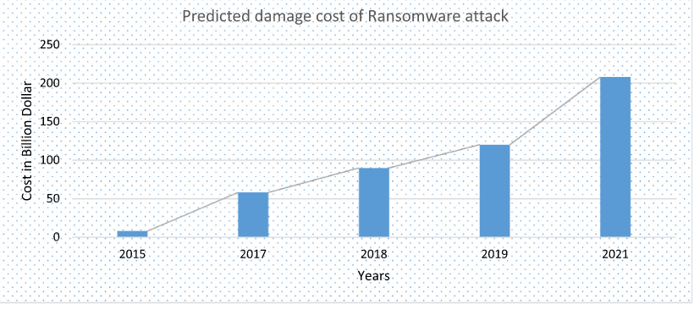

*Figure 1: predicted damage cost of a ransomware attack five years ago*

Given the high level of danger, sophisticated methods as described above show the need to provide awareness to researchers and academic members about the importance of attack tools, how their operation? What can recovery measures be? In case, if an organization or individual becomes the target of a Ransomware attack? And this is only possible by providing a detailed picture of the ransomware attack tools.

**According to my research, many ransomware reports are not detailed and specific. In this article, I will try to synthesize personal opinions or fill in the gaps about ransomware that may not have been mentioned to give you the most detailed and complete picture. about ransomware like the evolution of ransom, taxonomy, ransom should be paid or not, key ransomware challenges, and prevention techniques.**

# II. Literature survey

In this section, we provide a detailed overview of the current state of Ransomware attacks. This section consists of 4 subsections and each section provides the user with relevant knowledge to understand the details of the Ransomware attack. Section 2.1 provides the development of Ransomware attacks and why and why cybercriminals use trading virtual currency. Section 2.2 describes how are ransomware attacks and two main types of Ransomware details and some of the ransomware variants. Section 2.3 will evaluate the positive and negative about paying the ransom when attacked by ransomware. This document ends in section 2.4 providing the main challenges of Ransomware attacks along with prevention techniques.

To have an in-depth and comprehensive view of them, I have collected many books, articles published by the Institute of Electrical and Electronics Engineers (IEEE), ScienceDirect, Wikipedia, OReilly, crowdstrike and many data sources searched on google scholar for discussion and analysis. Find out the key limitations along with how we can improve and deliver better solutions for each of them.

## Evolution of ransomware

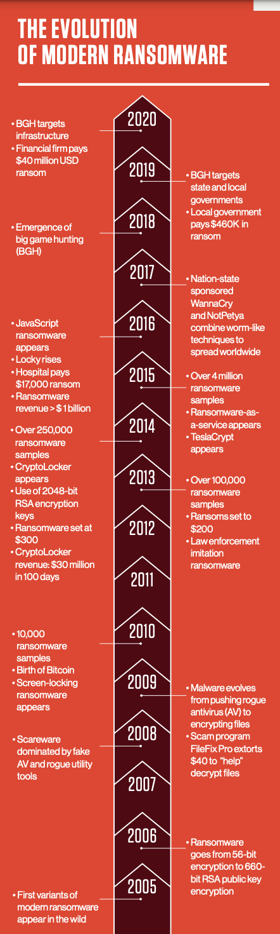Figure 2: evolution of ransomware

Although over the years, we still regularly see ransomware appearing on several cybersecurity sites and in many scientific journals. Ransomware is made with the idea of ​​evaluating the files of the worker by encrypting the files and will interfere with your system when you access the files or use some method so that you cannot execute the file. Do your job with that file and then request to send the money back within a certain period. That implementation method is quite old.

*In the late 1980s, criminals were already holding encrypted files hostage in exchange for cash sent via the postal service.****One of the first ransomware attacks ever documented was the AIDS trojan (PC Cyborg Virus)****that was released via floppy disk in 1989. Victims needed to send $189 to a P.O. box in Panama to restore access to their systems, even though it was a simple virus that utilized symmetric cryptography.*

fig 2 will show you the history of ransomware over the years. Specifically, the initial five ransomware when it appeared did not pay much attention and until 2010, with the appearance of bitcoin, ransomware became a lucrative and rapid development. *eCrime – a broad category of malicious activity that includes all types of cybercrime attacks, including malware, banking trojans, ransomware, mineware (cryptojacking), and crimeware because not all victims know how to transact with bitcoins*. But it is still increasing rapidly, nowadays even high school students in a developing country like Vietnam know bitcoin and even know how to use virtual money. Because of that, we see the tremendous growth of the ransomware crime industry. As for why cybercriminals choose bitcoin, choose the virtual currency for transactions is because: Bitcoin exchanges provided adversaries the means of receiving instant payments while maintaining anonymity, all transacted outside the strictures of traditional financial institutions.

## RANSOMWARE attack

**In this section, I will answer for you three main questions. Firstly, how does a ransomware attack, secondly the types and turns them into ransomware, thirdly, is ransomware the trend of the times?**

### First, how is the attack ransomware?

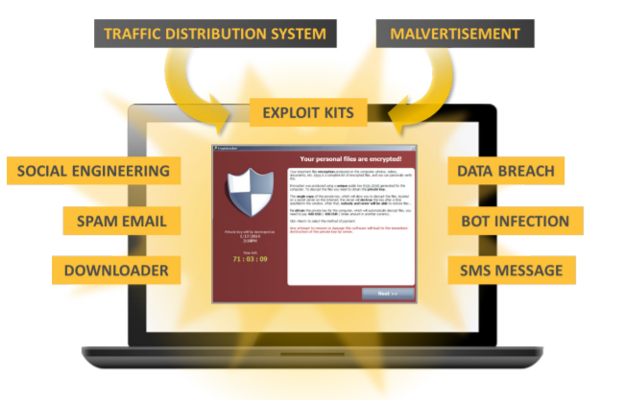

Figure 3: Routes for ransomware to arrive on a computer

Today, ransomware is commonly distributed through highly targeted phishing emails, social engineering schemes, vulnerability attacks, or malicious ad networks. In most cases, the victim will click on a malicious link that introduces the ransomware variant on their device. Once a device or system is infected, the ransomware works immediately to identify and encrypt the victim's files. Once the data has been encrypted, a decryption key is required to unlock the file. To obtain the decryption key, the victim must follow instructions left on the ransom note stating how to pay the attacker - usually in Bitcoin. Threat actors rely on personal and business users becoming so frantic about regaining timely access to data that they will be willing to offer a hefty ransom for the decryption key. required to unlock data.

### Types of ransomware

As a research article once said:

*“Despite having similar objectives, the approaches taken by each type of ransomware are quite different”*

Therefore, to facilitate the evaluation and analysis of the methods of cybercriminals in ransomware, although ransomware has many variants and is difficult to identify ransomware will be divided into 2 main types and some exceptions.

Two main types of ransomware:

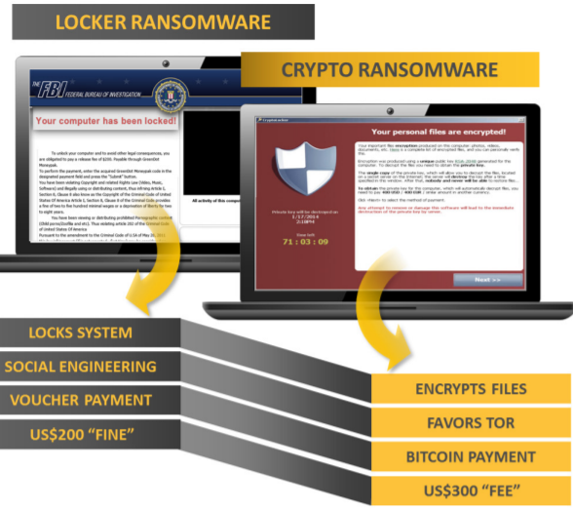

Figure 4: Two main types of ransomwares are locker ransomware and crypto-ransomware

**Screen Lockers:**

*Locker ransomware is designed to deny access to computing resources. This typically takes the form of locking the computer’s or device’s user interface and then asking the user to pay a fee to restore access to it. Locked computers will often be left with limited capabilities, such as only allowing the user to interact with the ransomware and pay the ransom. This means access to the mouse might be disabled and the keyboard functionality might be limited to numeric keys, allowing the victim to only type numbers to indicate the payment code.*

**Crypto ransomware or encryptors:**

*This type of ransomware is designed to find and encrypt valuable data stored on the computer, making the data useless unless the user obtains the decryption key*

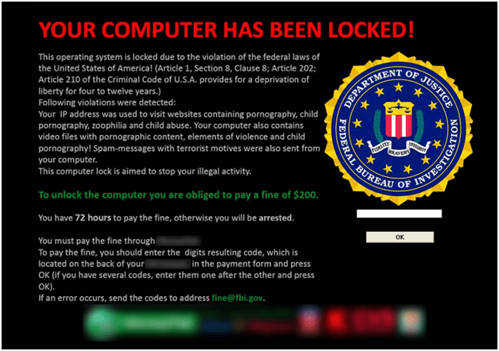

Figure: example of locker ransomware

**As for the screen locker**, we can see that it only locks the screen and our controls. As a result, nearly all files are recoverable, and ransomware can be deleted to restore the computer to its original state. That is also one of its weaknesses, making it weaker than other ransomware that destroys more data because victims may not be too scared if they know they are attacked by lock ransomware. For that reason, usually, ransomware attacks will often pretend to be a government or a legal agency that sends a penalty request for some reason. It may seem less effective for some individuals, but it is very effective for some cases with limited user interaction because we can't perform some recovery methods, or we can't lose its files because may be fined…

***From that, we can see it will be a big potential today when wearable devices and IoT are on the throne.***

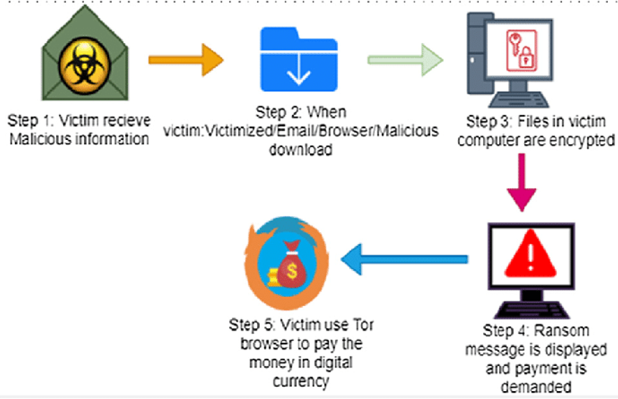

Figure: crypto ransomware: how to attack

**With crypto ransomware**, we can have a small example. If the victim loses data, such as memories with his lover or confidential company data urgently. They will certainly accept to pay hundreds of dollars for the return.

So why does crypto-only take files that are important to the object, or do it take all the files of the object and then encrypt it? Here, after the computer installs crypto ransomware, it will hide in the computer and search for important data with the victim without the computer knowing it exists. By the time the computer receives the notification, it has finished encrypting the important files it finds. And here the computer will be able to access and use it normally but cannot access and infected files. If you want to access those files, you will have to enter the code it provides. Usually, the cost to get back such files will be much higher than the cost of getting the code from cybercriminals. That's why when infected Crypto ransomware victims tend to pay more.

*The way ransomware identifies files as important is by entropy, a measure of a file that refers to a random unit -Shannon entropy. It is a measure of the randomness of the data in the file on a hierarchy from 1-8, usually text files are low-level. And compressed encrypted files have a high value*. So don't think that it will miss your important files, but help you delete junk files because no one will compress junk files again.

**From there, we can see that crypto ransomware is more dangerous than lock ransomware, so criminals, tend to be more prone to crypto ransomware.**

**Ransomware is evolving as strongly as covid, so it has too many more contagious and more dangerous variants. The trend of ransomware is more destructive to the victim's data (the victim does not pay the ransom, the data will be automatically deleted - cryptolocker, super-infection -WannaCry...). So, ransomware can be understood as the trend of the times when it directly interacts with the victim without having to go through an intermediary like other malware.**

## Ransom should be paid or not

This is just a small part of ransomware variants; it can be seen that this ransomware industry is very developed and diverse. So, is paying the ransom right or wrong?

**If a business or an individual is attacked by ransomware, should they return the money or not to the individual just need to answer 2 questions? Worth the ransom or the more valuable data? Does money definitely convert data? Also, for a group or the cybersecurity industry, is paying ransom an incentive for cybercriminals?**

*The FBI does not support paying a ransom in response to a ransomware attack. They argue paying a ransom not only encourages the business model, but also may go into the pockets of terror organizations, money launderers, and rogue nation-states. Moreover, while few organizations publicly admit to paying ransoms, adversaries will publicize that info on the dark web – making it common knowledge for other adversaries looking for a new target.*

Ransomware criminals seem to have enough business sense to realize that if there is a rumor that they will not provide a decryption code after the ransom is paid; Their business model will fail, and the victim will stop paying. Some ransomware schemes try to build trust by decrypting a few files before paying the ransom. Software to make you believe that scope can send you data We have used many methods such as:

Figure 4: CTBLocker offers a “try-before-you-buy” service

Trojan.Cryptlocker. G has the option to decrypt five randomly selected files for free. In other cases, corporate victims can negotiate lower fees.

I will give some cases of attacks that can be redeemed by some agencies as noted:

Some of the victim's records are important to them. For women can be some sensitive files. For another, it could be some file that stores their important information like memories they don't want to forget or data about a job they're doing. That's why it's common to pay for ransomware.

**But in my opinion: I still like the saying "*it hurts once then hurts many times*"**

**So not giving the ransom is more reasonable because:**

* **you become a bigger goal**
* **criminals will tell each other you pay and will be targeted for other cybercriminals**
* **Criminals probably won't decrypt your data, although the probability is low**
* **your next ransom will be higher**
* **your payment encourages criminals to keep doing what they are doing.**

## prevention techniques

# III.Conclusions

# IV.References